**Experiment No 5**

Design and develop a model for predicting house prices.

**Objective:**

At the end of this practical session, student will be able to predict the house prices with regression based Deep Learning Model.

**Theory:**

1. **Regression:**

Regression is a method of modeling a target value based on independent predictors. This method is mostly used for forecasting and finding out cause and effect relationship between variables. It consists of predicting a continuous value instead of a discrete label: for instance, predicting the temperature tomorrow, given meteorological data; or predicting the time that a software project will take to complete, given its specifications.

While developing a deep neural network for regression, neural network should end with a single unit and no activation (it will be a linear layer). This is a typical setup for scalar regression (a regression where output is to predict a single continuous value).

1. **K-corss validation:**

A neural network is evaluated by adjusting its parameters. For this dataset is divided into a training set and a validation set. But, with few data points in dataset, the validation set would end up being very small. As a consequence, the validation scores might change a lot depending on which data points you chose to use for validation and which you chose for training. This would prevent you from reliably evaluating your model. The best practice in such situations is to use K-fold cross-validation as shown in following figure.

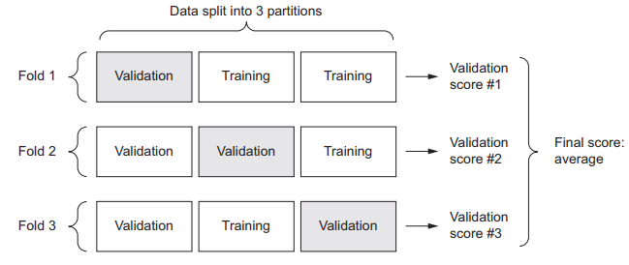

Figure: 3-fold cross validation

It consists of splitting the available data into K partitions (typically K = 4 or 5), instantiating K identical models, and training each one on K – 1 partitions while evaluating on the remaining partition. The validation score for the model used is then the average of the K validation scores obtained.

**Keyword:**

Regression, K-fold validation

**Procedure:**

1. Load boston housing price dataset form keras databases
2. Prepare the data by normalizing the input features
3. Design the network for predicting house prices
4. Build the neural network
5. Validate approach using K-fold validation
6. Build the history of successive mean K-fold validation scores
7. Plot validation scores